Coding Lesson 1 - Output, Input and Variables

|  |
| --- |
| **Mild - perfect for beginners** |

Using the starter file -<https://scratch.mit.edu/projects/342271975/>

1. Make the sprite say “**I love programming**”
2. Try the hide block - what does this do? - **This will hide every bit of code and hide the sprite so that nothing will appear on the screen.**
3. How did you get the sprite to reappear? - **By using the show block after hide, everything will reappear.**
4. Make the sprite say **“Welcome to Computer Science!”**
5. Ask a question and output the answer three times, with the format, **“ (Your Question) - Your answer will be displayed three times.”**
6. Ask the user for their name and age. Make the sprite say: “**Hello [name]”**  then “**You are [age]**”
7. Click the sound menu - and try the **play sound** block.
8. Record a new sound for the Sprite to play. When recording and playing sounds, what is the output and what is the input? - **Output is the sound that comes out when the sound block is used, the input is the sound file that is being used.**

Finished Example - <https://scratch.mit.edu/projects/332737235/>

|  |
| --- |
| **Medium - expanding your skills** |

Using the starter file - <https://scratch.mit.edu/projects/342586555/> 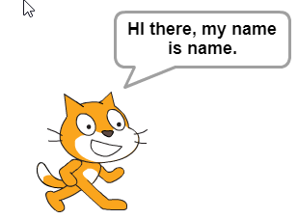

Editing variables, adding 1 to variable

1. Add a second sprite and have them say hello to each other.
2. Input two words and have the sprite say them backwards.
3. Why is the variable name ***age*** better than ***x***? – **Being able to go back and look at your code and see variable names that make sense with what they are being used for make it easier to debug and understand your code when going back through it.**
4. What is wrong with the Scratch program to the right? – **They set the variable name = name; instead of taking in the user input and setting it to name.**
5. Write the code to input a word and print it to the screen. What happens in the last problem if you type in a number instead of a word? – **It still works.**

Finished Example - <https://scratch.mit.edu/projects/332756450/>

|  |
| --- |
| **Spicy - looking for a challenge?** |

Using the starter file - <https://scratch.mit.edu/projects/342599075/>

1. Ask the user for their name and an adjective. Make the sprite say “**Hi there [adjective] [name], I am glad to meet you.**”
2. Ask the user to input two adjectives. Print "**The ___ pig is ___.**”
3. Input three words and have the sprite say them backwards.
4. Input your initials and print a monogram. My initials are RED and my monogram would be RDE.
5. Input a number and add 25. Have the Sprite say the answer.

Finished Example - <https://scratch.mit.edu/projects/332765449/>